**A**

**LAB REPORT**

**ON**

**Artificial Intelligence**

**By**

**Sayog Rai**

**Exam Roll No:13081/21**



**Submitted to:**

**Mr. Kul Prasad Paudel**

**Department of Management**

**Kantipur College of Management and Information Technology**

In partial fulfillment of the requirements for the Course

Artificial Intelligence

Mid Baneshwor, Kathmandu

October, 2024

Table of Contents

**1** **Write a program to implement BFS** 2

**1.1** **Source Code** 2

**1.2** **Output** 4

**2** **Write a program to implement DFS** 5

**2.1** **Source Code** 5

**2.2** **Output** 8

**3** **Write a program to implement Tower of Hanoi Problem** 8

**3.1** **Source Code** 8

**3.2** **Output** 8

**4** **Write a program to demonstrate Bidirectional Search** 9

**4.1** **Source Code** 9

**4.2** **Output** 11

**5** **Write a program to demonstrate Greedy Best Search** 12

**5.1** **Source code** 12

**5.2** **Output** 13

**6** **Write a program to demonstrate A* search algorithm** 14

**6.1** **Source code** 14

**6.2** **Output** 16

**7** **Write a program to demonstrate Hill Climbing Algorithm** 16

**7.1** **Source code** 16

**7.2** **Output** 17

**8** **Write a program to demonstrate min max algorithm** 18

**8.1** **Source code** 18

**8.2** **Output** 21

**9** **Write a program to demonstrate alphabeta** 22

**9.1** **Source code** 22

**9.2** **Output** 25

**10** **Write a program to demonstrate bidirectional search** 26

**10.1** **Source code** 26

**10.2** **Output** 29

# **Write a program to implement BFS**

## **Source Code**

from collections import deque

class Node:

def __init__(self, data=0):

self.data = data

self.left = None

self.right = None

class Tree:

def __init__(self):

self.head = None

def is_empty(self):

return self.head is None

def insert(self, n):

new_node = Node(n)

if self.is_empty():

self.head = new_node

else:

ptr = self.head

prev = None

while ptr:

prev = ptr

if new_node.data > ptr.data:

ptr = ptr.right

else:

ptr = ptr.left

if new_node.data > prev.data:

prev.right = new_node

else:

prev.left = new_node

def bfs(self):

if self.head is None:

return

queue = deque([self.head])

while queue:

current = queue.popleft()

self.visit(current)

if current.left:

queue.append(current.left)

if current.right:

queue.append(current.right)

@staticmethod

def visit(node):

print(node.data, end=", ")

def search(self, el):

ptr = self.head

lvl = 0

while ptr:

if el == ptr.data:

print(f"{el} Found at level {lvl}!")

return ptr

elif el > ptr.data:

ptr = ptr.right

else:

ptr = ptr.left

lvl += 1

print(f"{el} Not Found!")

return None

if __name__ == "__main__":

ob = Tree()

while True:

user_input = input("Enter a number for BFS (or type 'done' to stop): ")

if user_input.lower() == 'done':

break

try:

ob.insert(int(user_input))

except ValueError:

print("Please enter a valid integer or 'done' to stop.")

print("BFS: ", end="")

ob.bfs()

print()

search_number = int(input("Enter a number to search: "))

ob.search(search_number)

## **Output**

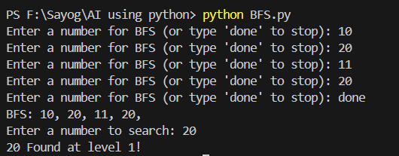

# **Write a program to implement DFS**

## **Source Code**

class Node:

def __init__(self, data=0):

self.data = data

self.left = None

self.right = None

class Tree:

def __init__(self):

self.head = None

def is_empty(self):

return self.head is None

def insert(self, n):

new_node = Node(n)

if self.is_empty():

self.head = new_node

else:

ptr = self.head

prev = None

while ptr:

prev = ptr

if new_node.data > ptr.data:

ptr = ptr.right

else:

ptr = ptr.left

if new_node.data > prev.data:

prev.right = new_node

else:

prev.left = new_node

def preorder(self, ptr):

if ptr is not None:

self.visit(ptr)

self.preorder(ptr.left)

self.preorder(ptr.right)

def inorder(self, ptr):

if ptr is not None:

self.inorder(ptr.left)

self.visit(ptr)

self.inorder(ptr.right)

def postorder(self, ptr):

if ptr is not None:

self.preorder(ptr.left)

self.preorder(ptr.right)

self.visit(ptr)

@staticmethod

def visit(node):

print(node.data, end=", ")

def search(self, el):

ptr = self.head

lvl = 0

while ptr:

if el == ptr.data:

print(f"{el} found in {lvl}th level!")

return ptr

elif el > ptr.data:

ptr = ptr.right

lvl += 1

else:

ptr = ptr.left

lvl += 1

print(f"{el} not found!")

return None

if __name__=="__main__":

ob = Tree()

while True:

user_input = input("Enter a number for DFS (or 'done' to stop):")

if user_input.lower() == "done":

break

try:

number = int(user_input)

ob.insert(number)

except ValueError:

print("Please enter a valid number.")

print("preorder: ", end="")

ob.preorder(ob.head)

print()

print("inorder: ", end="")

ob.inorder(ob.head)

print()

print("postorder: ", end="")

ob.postorder(ob.head)

print()

search_value = int(input("Enter a number to search: "))

ob.search(search_value)

## **Output**

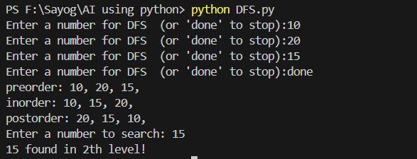

# **Write a program to implement Tower of Hanoi Problem**

## **Source Code**

def move(n, from_rod, to_rod, aux_rod):

if n == 1:

print(f"Move top disk from {from_rod} to {to_rod}")

return

move(n - 1, from_rod, aux_rod, to_rod)

move(1, from_rod, to_rod, aux_rod)

move(n - 1, aux_rod, to_rod, from_rod)

if __name__ == "__main__":

n = 3

move(n,"A","C","B")

## **Output**

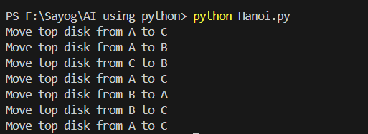

# **Write a program to demonstrate Bidirectional Search**

## **Source Code**

from collections import deque

class Node:

def __init__(self, state, parent=None):

self.state = state

self.parent = parent

def get_path(self):

path = []

current = self

while current:

path.append(current.state)

current = current.parent

return path[::-1]

def bidirectional_search(start_state, goal_state):

if start_state == goal_state:

return Node(start_state)

start_frontier = deque([Node(start_state)])

goal_frontier = deque([Node(goal_state)])

explored_from_start = {start_state: True}

explored_from_goal = {goal_state: True}

while start_frontier and goal_frontier:

if start_frontier:

start_node = start_frontier.popleft()

if start_node.state in explored_from_goal:

return join_paths(start_node, start_node.state, explored_from_goal)

for neighbor in expand(start_node):

if neighbor.state not in explored_from_start:

explored_from_start[neighbor.state] = True

start_frontier.append(neighbor)

if goal_frontier:

goal_node = goal_frontier.popleft()

if goal_node.state in explored_from_start:

return join_paths(goal_node, goal_node.state, explored_from_start)

for neighbor in expand(goal_node):

if neighbor.state not in explored_from_goal:

explored_from_goal[neighbor.state] = True

goal_frontier.append(neighbor)

return None

def join_paths(node, meeting_point, explored):

path_from_start = node.get_path()

path_from_goal = []

current = meeting_point

while current in explored:

path_from_goal.append(current)

current = explored[current]

return path_from_start + path_from_goal[::-1][1:]

def expand(node):

children = []

for i in range(1, 4):

child_state = f"{node.state}-{i}"

child_node = Node(child_state, parent=node)

children.append(child_node)

return children

if __name__ == "__main__":

start = "A"

goal = "A-3"

result_node = bidirectional_search(start, goal)

if result_node:

print("Goal found!")

print("Path to goal:", " -> ".join(result_node))

else:

print("Goal not found.")

## **Output**

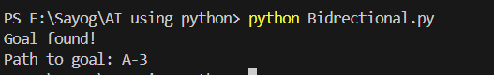

# **Write a program to demonstrate Greedy Best Search**

## **Source code**

from queue import PriorityQueue

class Node:

def __init__(self, state, heuristic, parent=None):

self.state = state

self.heuristic = heuristic

self.parent = parent

def __lt__(self, other):

return self.heuristic < other.heuristic

def get_path(self):

path = []

current = self

while current:

path.append(current.state)

current = current.parent

return path[::-1]

def greedy_best_first_search(start_state, goal_state, heuristic):

start_node = Node(start_state, heuristic[start_state])

frontier = PriorityQueue()

frontier.put(start_node)

explored = set()

while not frontier.empty():

current_node = frontier.get()

if current_node.state == goal_state:

return current_node.get_path()

explored.add(current_node.state)

for neighbor in expand(current_node.state):

if neighbor not in explored:

neighbor_node = Node(neighbor, heuristic.get(neighbor, float('inf')), current_node)

frontier.put(neighbor_node)

return None

def expand(state):

return [f"{state}-{i}" for i in range(1, 4)]

if __name__ == "__main__":

heuristic = {

"A": 6,

"A-1": 5,

"A-2": 4,

"A-3": 3,

"A-1-1": 4,

"A-1-2": 2,

"A-2-1": 2,

"A-2-2": 1,

"A-3-1": 2,

"A-3-2": 0,

"A-3": 0

}

start = "A"

goal = "A-3-2"

result_path = greedy_best_first_search(start, goal, heuristic)

if result_path:

print("Goal found!")

print("Path to goal:", " -> ".join(result_path))

else:

print("Goal not found.")

## **Output**

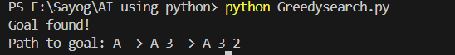

# **Write a program to demonstrate A* search algorithm**

## **Source code**

from queue import PriorityQueue

class Node:

def __init__(self, state, g, h, parent=None):

self.state = state

self.g = g

self.h = h

self.f = g + h

self.parent = parent

def __lt__(self, other):

return self.f < other.f

def get_path(self):

path = []

current = self

while current:

path.append(current.state)

current = current.parent

return path[::-1]

def a_star_search(start_state, goal_state, heuristic):

start_node = Node(start_state, 0, heuristic[start_state])

frontier = PriorityQueue()

frontier.put(start_node)

explored = set()

while not frontier.empty():

current_node = frontier.get()

if current_node.state == goal_state:

return current_node.get_path()

explored.add(current_node.state)

for neighbor in expand(current_node.state):

g = current_node.g + 1

h = heuristic.get(neighbor, float('inf'))

neighbor_node = Node(neighbor, g, h, current_node)

if neighbor not in explored:

frontier.put(neighbor_node)

return None

def expand(state):

return [f"{state}-{i}" for i in range(1, 4)]

if __name__ == "__main__":

heuristic = {

"A": 6,

"A-1": 5,

"A-2": 4,

"A-3": 3,

"A-1-1": 4,

"A-1-2": 2,

"A-2-1": 2,

"A-2-2": 1,

"A-3-1": 2,

"A-3-2": 0,

"A-3": 0

}

start = "A"

goal = "A-3-2"

result_path = a_star_search(start, goal, heuristic)

if result_path:

print("Goal found!")

print("Path to goal:", " -> ".join(result_path))

else:

print("Goal not found.")

## **Output**

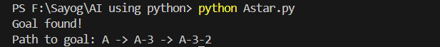

# **Write a program to demonstrate Hill Climbing Algorithm**

## **Source code**

import random

class HillClimbing:

def __init__(self, objective_function):

self.objective_function = objective_function

def get_neighbors(self, current_state):

return [current_state + step for step in [-1, 1]]

def search(self, initial_state):

current_state = initial_state

current_value = self.objective_function(current_state)

while True:

neighbors = self.get_neighbors(current_state)

next_state = None

next_value = current_value

for neighbor in neighbors:

neighbor_value = self.objective_function(neighbor)

if neighbor_value > next_value:

next_value = neighbor_value

next_state = neighbor

if next_state is None:

break

current_state = next_state

current_value = next_value

return current_state, current_value

def objective_function(x):

return -1 * (x**2) + 10 * x # Example function: A downward-facing parabola

if __name__ == "__main__":

hc = HillClimbing(objective_function)

initial_state = random.randint(0, 10)

result = hc.search(initial_state)

print(f"Initial State: {initial_state}")

print(f"Optimal State: {result[0]}")

print(f"Optimal Value: {result[1]}")

## **Output**

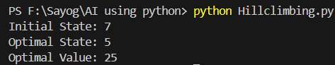

# **Write a program to demonstrate min max algorithm**

## **Source code**

import random

class TicTacToe:

def __init__(self):

self.board = [' ' for _ in range(9)]

self.current_player = 'X'

def print_board(self):

for i in range(3):

print('|'.join(self.board[i*3:(i+1)*3]))

if i < 2:

print('-----')

def is_winner(self, player):

win_conditions = [

(0, 1, 2), (3, 4, 5), (6, 7, 8),

(0, 3, 6), (1, 4, 7), (2, 5, 8),

(0, 4, 8), (2, 4, 6)

]

return any(all(self.board[i] == player for i in condition) for condition in win_conditions)

def is_draw(self):

return ' ' not in self.board

def minimax(self, depth, is_maximizing):

if self.is_winner('X'):

return 1

elif self.is_winner('O'):

return -1

elif self.is_draw():

return 0

if is_maximizing:

best_score = float('-inf')

for i in range(9):

if self.board[i] == ' ':

self.board[i] = 'X'

score = self.minimax(depth + 1, False)

self.board[i] = ' '

best_score = max(score, best_score)

return best_score

else:

best_score = float('inf')

for i in range(9):

if self.board[i] == ' ':

self.board[i] = 'O'

score = self.minimax(depth + 1, True)

self.board[i] = ' '

best_score = min(score, best_score)

return best_score

def best_move(self):

best_score = float('-inf')

move = -1

for i in range(9):

if self.board[i] == ' ':

self.board[i] = 'X'

score = self.minimax(0, False)

self.board[i] = ' '

if score > best_score:

best_score = score

move = i

return move

def player_move(self):

while True:

try:

move = int(input("Enter your move (1-9): ")) - 1

if self.board[move] == ' ':

self.board[move] = 'O'

break

else:

print("Invalid move! Try again.")

except (ValueError, IndexError):

print("Invalid input! Please enter a number between 1 and 9.")

if __name__ == "__main__":

game = TicTacToe()

while True:

game.print_board()

if game.is_draw():

print("It's a draw!")

break

if game.is_winner('O'):

print("O wins!")

break

game.player_move()

if game.is_draw():

game.print_board()

print("It's a draw!")

break

if game.is_winner('O'):

game.print_board()

print("O wins!")

break

print("AI's turn (X):")

move = game.best_move()

if move != -1:

game.board[move] = 'X'

if game.is_winner('X'):

game.print_board()

print("X wins!")

break

## **Output**

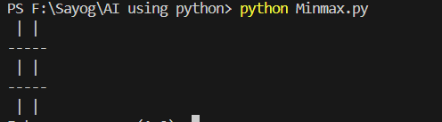

# **Write a program to demonstrate alphabeta**

## **Source code**

class TicTacToe:

def __init__(self):

self.board = [' ' for _ in range(9)]

self.current_player = 'X'

def print_board(self):

for i in range(3):

print('|'.join(self.board[i*3:(i+1)*3]))

if i < 2:

print('-----')

def is_winner(self, player):

win_conditions = [

(0, 1, 2), (3, 4, 5), (6, 7, 8),

(0, 3, 6), (1, 4, 7), (2, 5, 8),

(0, 4, 8), (2, 4, 6)

]

return any(all(self.board[i] == player for i in condition) for condition in win_conditions)

def is_draw(self):

return ' ' not in self.board

def minimax(self, depth, alpha, beta, is_maximizing):

if self.is_winner('X'):

return 1

elif self.is_winner('O'):

return -1

elif self.is_draw():

return 0

if is_maximizing:

best_score = float('-inf')

for i in range(9):

if self.board[i] == ' ':

self.board[i] = 'X'

score = self.minimax(depth + 1, alpha, beta, False)

self.board[i] = ' '

best_score = max(score, best_score)

alpha = max(alpha, best_score)

if beta <= alpha:

break

return best_score

else:

best_score = float('inf')

for i in range(9):

if self.board[i] == ' ':

self.board[i] = 'O'

score = self.minimax(depth + 1, alpha, beta, True)

self.board[i] = ' '

best_score = min(score, best_score)

beta = min(beta, best_score)

if beta <= alpha:

break

return best_score

def best_move(self):

best_score = float('-inf')

move = -1

alpha = float('-inf')

beta = float('inf')

for i in range(9):

if self.board[i] == ' ':

self.board[i] = 'X'

score = self.minimax(0, alpha, beta, False)

self.board[i] = ' '

if score > best_score:

best_score = score

move = i

return move

def player_move(self):

while True:

try:

move = int(input("Enter your move (1-9): ")) - 1

if self.board[move] == ' ':

self.board[move] = 'O'

break

else:

print("Invalid move! Try again.")

except (ValueError, IndexError):

print("Invalid input! Please enter a number between 1 and 9.")

if __name__ == "__main__":

game = TicTacToe()

while True:

game.print_board()

if game.is_draw():

print("It's a draw!")

break

if game.is_winner('O'):

print("O wins!")

break

game.player_move()

if game.is_draw():

game.print_board()

print("It's a draw!")

break

if game.is_winner('O'):

game.print_board()

print("O wins!")

break

print("AI's turn (X):")

move = game.best_move()

if move != -1:

game.board[move] = 'X'

if game.is_winner('X'):

game.print_board()

print("X wins!")

break

## **Output**

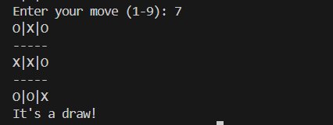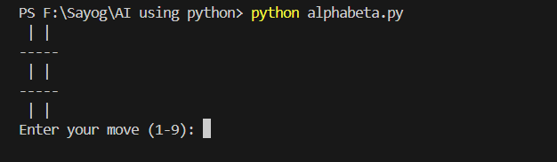

# **Write a program to demonstrate bidirectional search**

## **Source code**

from collections import deque

class Node:

def __init__(self, state, parent=None):

self.state = state

self.parent = parent

def get_path(self):

path = []

current = self

while current:

path.append(current.state)

current = current.parent

return path[::-1]

def bidirectional_search(start_state, goal_state):

if start_state == goal_state:

return Node(start_state)

start_frontier = deque([Node(start_state)])

goal_frontier = deque([Node(goal_state)])

explored_from_start = {start_state: True}

explored_from_goal = {goal_state: True}

while start_frontier and goal_frontier:

if start_frontier:

start_node = start_frontier.popleft()

if start_node.state in explored_from_goal:

return join_paths(start_node, start_node.state, explored_from_goal)

for neighbor in expand(start_node):

if neighbor.state not in explored_from_start:

explored_from_start[neighbor.state] = True

start_frontier.append(neighbor)

if goal_frontier:

goal_node = goal_frontier.popleft()

if goal_node.state in explored_from_start:

return join_paths(goal_node, goal_node.state, explored_from_start)

for neighbor in expand(goal_node):

if neighbor.state not in explored_from_goal:

explored_from_goal[neighbor.state] = True

goal_frontier.append(neighbor)

return None

def join_paths(node, meeting_point, explored):

path_from_start = node.get_path()

path_from_goal = []

current = meeting_point

while current in explored:

path_from_goal.append(current)

current = explored[current]

return path_from_start + path_from_goal[::-1][1:]

def expand(node):

children = []

for i in range(1, 4):

child_state = f"{node.state}-{i}"

child_node = Node(child_state, parent=node)

children.append(child_node)

return children

if __name__ == "__main__":

start = "A"

goal = "A-3"

result_node = bidirectional_search(start, goal)

if result_node:

print("Goal found!")

print("Path to goal:", " -> ".join(result_node))

else:

print("Goal not found.")

## **Output**

